West Hull Ladies
RRC

December Newsletter

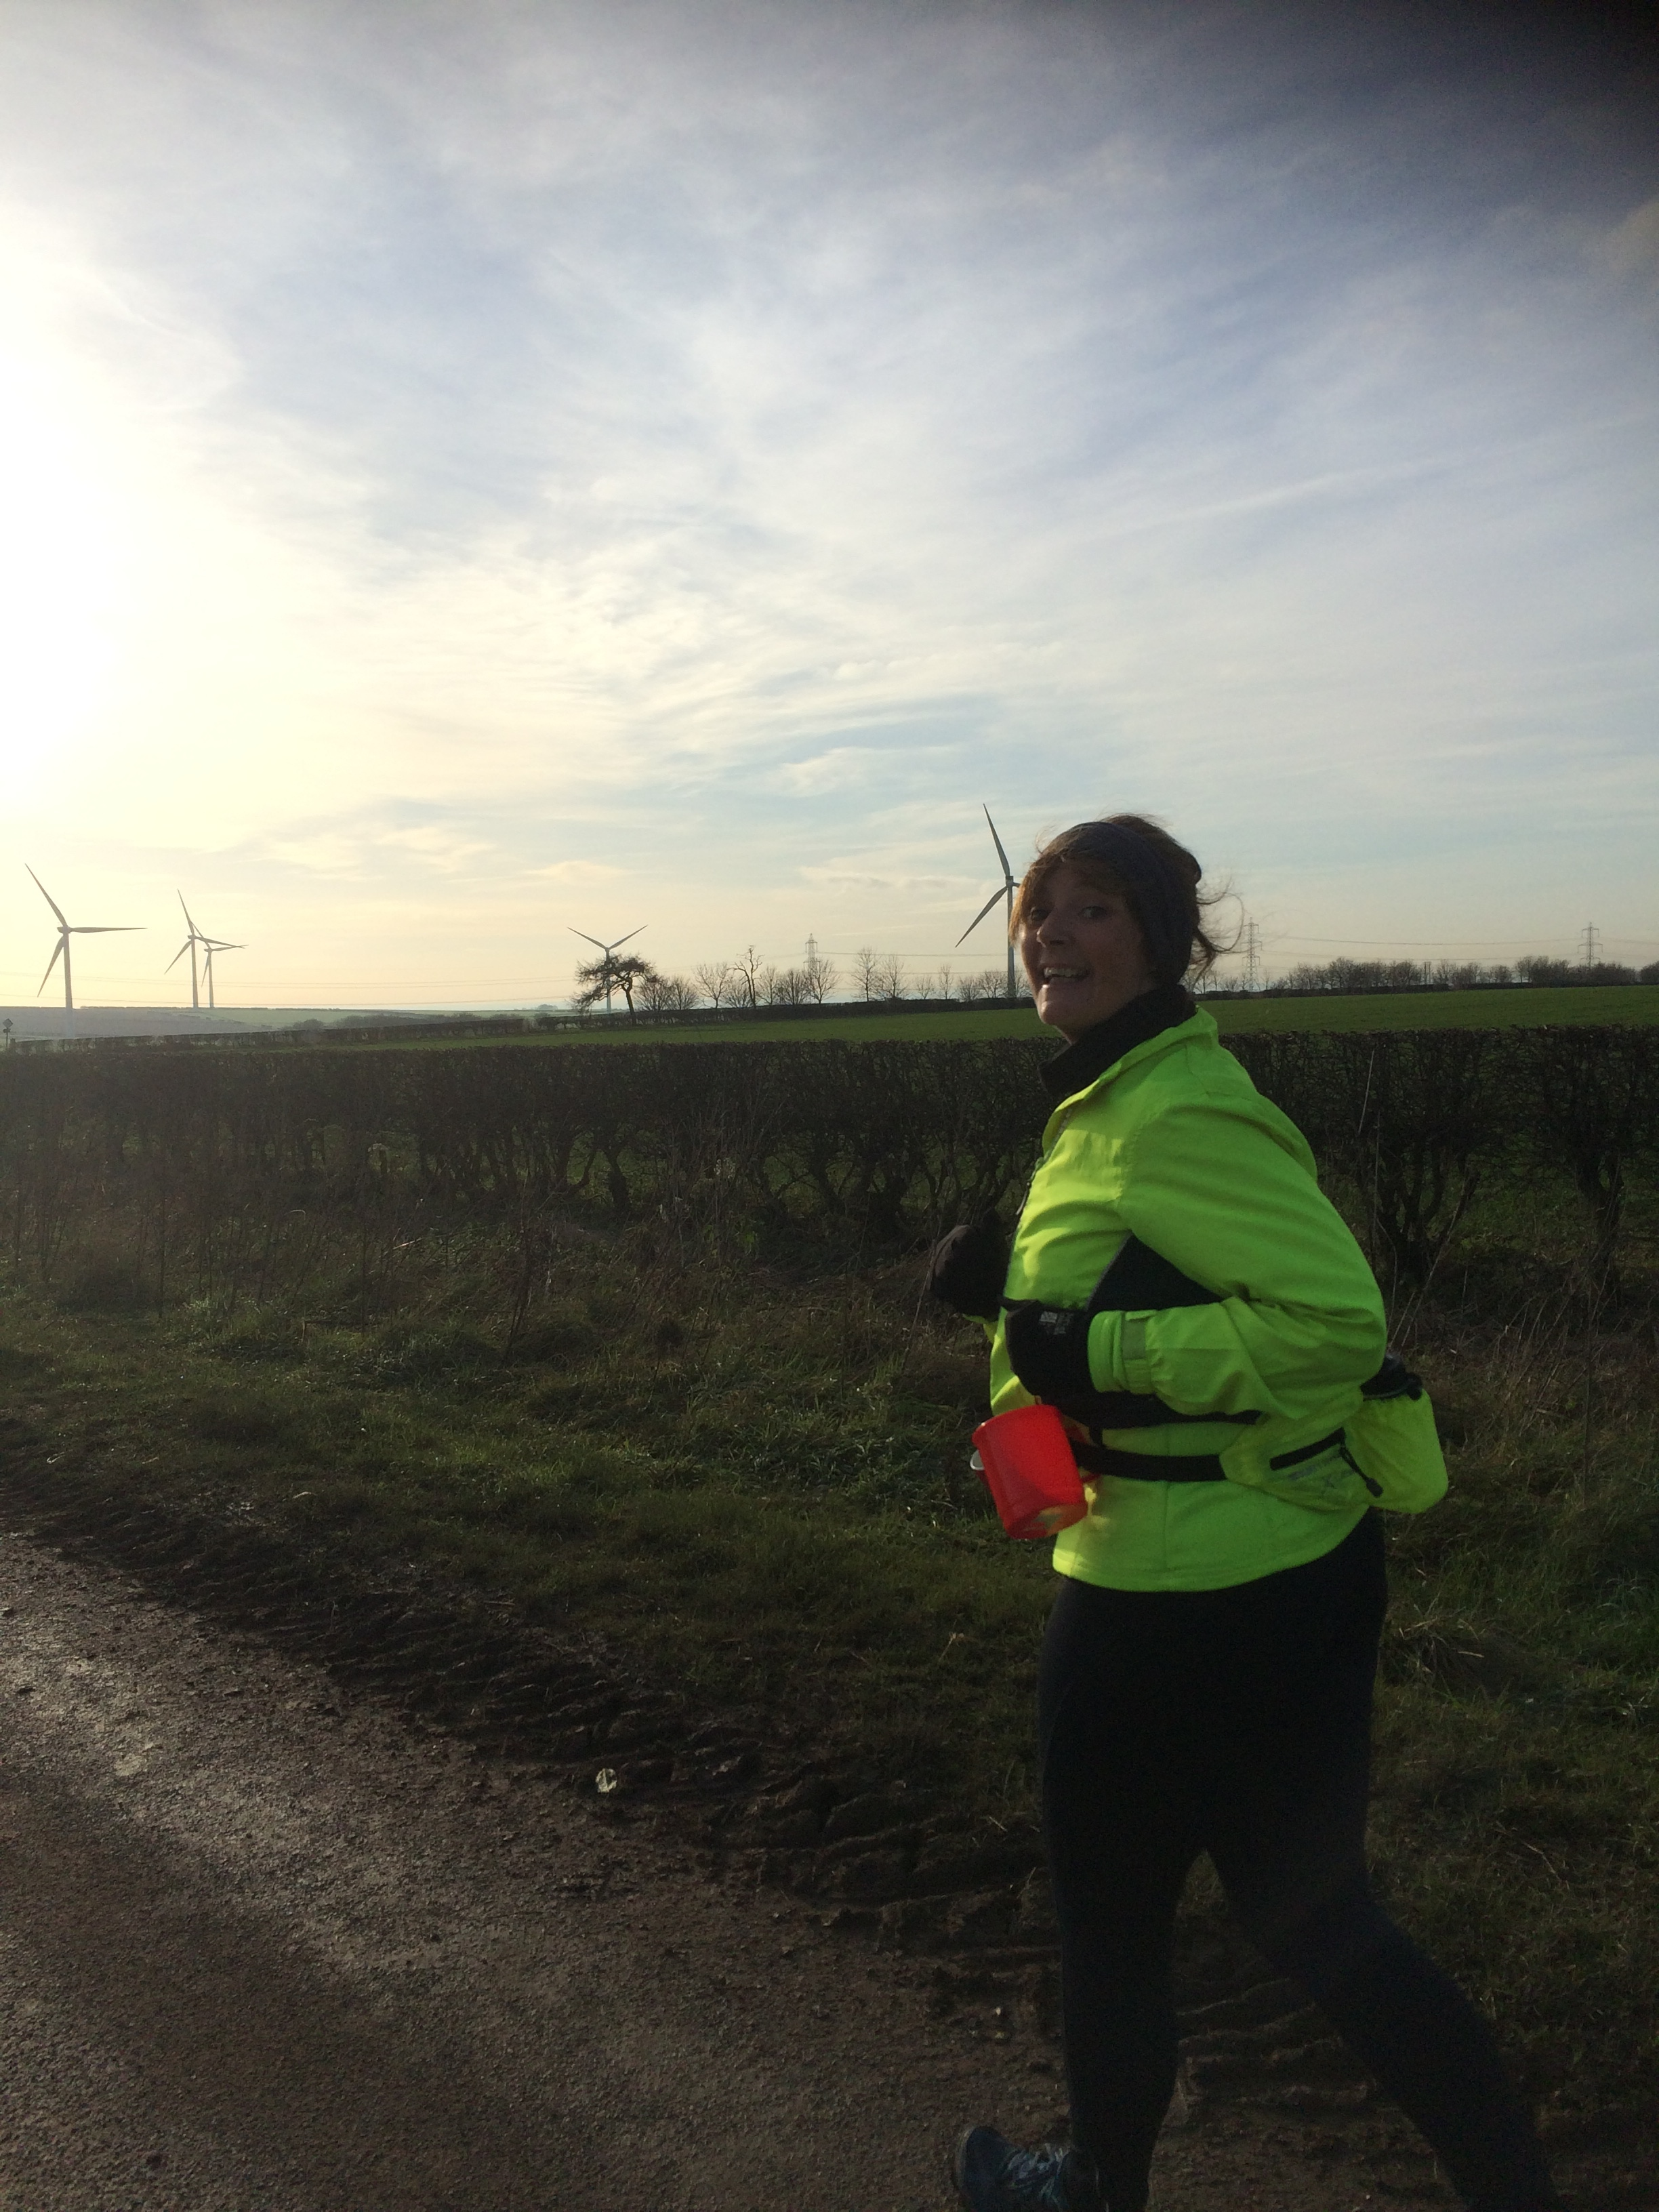

Rudolph Romp 6th December

West Hull Ladies

WEST HULL LADIES RRC COMMITTEE MEETING

Committee Meeting 1st December 2015

Minutes

Present, Sandra, Jill, Zoe, Linda, Karen S, Maria, Kristine, Amanda, Rachael

- Apologies from Annette, Hayley, Verity
- Minutes of previous meeting agreed as true record
- Matters arising from previous meeting and actions - Food Seminar - email had gone out but not many Ladies wanting to attend. Email had been circulated about anyone wishing to train as an ‘official’ for race meetings/training. Anna was coordinating our Club teams for the Hull Marathon. Heidi had been contacted about our preferred dates for workshops. As yet no response from Heidi. Maps had been made available for ladies wanting to run 3 miles+. Rachael updated that she had been in touch with Runnercare about kit and informed that they sourced it also from Ron Hill. Contact to be made with Exercise Direct as it was felt More Miles running clothing might be better for Ladies. Action - Sandra to contact Exercise Direct. Update - firm contacted will ring back next week when enquiries made. Jill updated that she had received many responses in relation to the Club London Marathon place ballot. These would be studied and put before the Committee at a later date for approval.
- 0-5k. Amanda updated. Stated that leaders had covered the dates required and buddies would volunteer nearer the date. 3 ladies already joined - asked all club members to ‘recruit’ ladies on to the course. Amanda also said that to organise this on top of all the work she already did was putting excessive demands on her time. Agreed that members be emailed to ask if anyone would be willing to take on this role next year. If so they could shadow Amanda this year to see what was needed. As everything was already in place the ‘job’ in isolation should not be too onerous for anyone. Action - Amanda to send out email.
- Amanda updated on the Hull Marathon. West Hull Ladies had offered to staff the water station at West Park and an additional 12 adult Marshalls were needed for the route in the park.
- Advent Calendar run. The date for this will be 22nd December and as there were now so many ladies the room at the YPI was booked for afterwards. Maria volunteered to do some baking and Amanda to sort mulled wine.
- Rachael had organised the gait analysis for Thursday 4.12.15. Ladies had been informed.
- Linda and Amanda spoke about the Club accounts, which was felt, should be audited every year and run from January - Dec 31st yearly. This was agreed and Linda and Amanda to meet to check. Audit to take place of accounts in January.
- Discussion about having AGM and Presentation evening separate. This was agreed and it was also agreed that 1. AGM to be held first Monday in March and 2. Presentation Evening be held on 27th March 2015 Back Room in Cottingham. Action Rachael to ascertain if date ok with the venue.

The Maravan 22nd November - Linda

I really don’t know why I agreed to do this Maravan event but there you go I did. Suddenly it was upon me so I couldn’t back out now!

I decided that seeing as I have entered the Rudolph Romp I would use this event as a training session, i.e. mileage, as the furthest I’d ran was 17 miles since the York marathon.

I’d made arrangements with Liz so we could travel together and set off from her house at 7am meeting up at the Trawlermen pub in Cleethorpes with Jill, Karen and Jane at 8am to collect our numbers, find the parking and the start. It had rained all night and was still raining at 6am but thankfully the rain had gone away when we arrived and it stayed away too, which I was thankful of, I hate getting soaked and 26.2 miles is a long way in the rain. There was a lot of standing water though and some of the route was a little bit off road which was very muddy.

We got going at 9am and ran together, Jane as part of a relay with Jill and Karen, Liz and myself. It was a little like orienteering though and the route wasn’t marked out properly so we (and a bunch of other runners) went the wrong way. Some of the leaders were none too pleased and we heard them grumble as they flew past us.

The route was in laps and we had to run seven in total. I loved that the finish line was also the water station and the relay swap over so every lap we had a little drink and chat to whoever was left waiting before carrying on. A very relaxed race (or event as I like to call it).

Finally I came to the last lap, boy was I pleased I sure was ready for this ‘event’ to be over. The last lap was quite a struggle, mentally as well as physically as I’d cockled over and hurt my foot and my knee was making a funny clicking noise. Anyway in the distance I could see Jane and Jill at the finish, Jill had a wonderful magic bag which consisted of porridge, tea, coffee, flap jack, even the kitchen sink, so she made me a hot cuppa along with a cup of porridge. She is such a star. While we waited for Liz and Karen to finish the final lap.

The medal was lovely as was the goody bag, bottle of beer, stick of Cleethorpes rock, chocolate bar, crisps, tin of lemonade. Not bad for a Saturday.

What I would like to add though is the WHL company was, as always, fantastic. We had fun, made some running friends on the southbank and as always the support was superb. Thank you ladies you made my Saturday fun.

Vale of York Half Marathon 23rd November – Jane

After an early start of 5.30am I set off for Karen’s at 7am in thick fog.
After changing cars we set up the sat nav on Karen’s phone and we were off. We arrived at Sherburn Aero club with plenty of time to spare and collected our packs, which contained pins, numbers, chips and information (well organised).
Before we knew it we were headed for start and we were off. Karen set off quite quickly so I kept her in view. For myself however I knew that steady was the way for me if I was going to stand a chance at this race. The weather was glorious, not a cloud in the sky. I trundled on. It was warm and as I weaved through the course was grateful when we hit a shady bit let alone the 3 water stations. The last 3 miles felt like 10, and me and another lady were overtaking each other on a regular basis along the never ending road. The road home, we thought can't be long now, round the bend it must be. Not this one, another stretch then finally we saw the finish in the distance and Karen cheering me on as I finally sprinted over the line.
Yippee! I’ve done it!! I was elated. No PB but my second half marathon this year and I really enjoyed it as I stayed positive throughout. Thanks Karen for training with me being great

company and a true friend!
I recommend this course to anyone as its flat with a couple of bumps, very well organised, and in a lovely location.

Rudolph Romp 6th December - Jane

When I was fuelled up on my usual porridge, banana and honey and my hub had very kindly defrosted my car I set off just after 7am to pick up the lovely Andrea and Hayley on way to Brantingham. We parked at Triton Inn car park and soon realised the drop in temperature as we stepped out the car. Oh my god its cold! Brrrr. Never mind we were all wrapped up and everyone had the right provisions with them.
We bundled into the hall where we were given our checkpoint card and number and met up with Jo, Lynne, Ros, Linda Sara and Rachael.

Andrea and Hayley were running as a pair so I slotted myself in behind the others. When we set off as I already knew, I wasn't going to maintain the pace of this group of ladies so let them go ahead and I trotted along on my own. I had discussed this option with my hub the night before so was mentally prepared and I knew the route backwards.
I could see the others just ahead so happy with my pace. It was cold as I trundled up the hill, through first gate then second chatting to fellow runners along the way. The steep field down to South Cave was a bit treacherous as still quite icy but I managed it no problem and arrived at first checkpoint in one piece.
I ran the next hill to the top so was quite chuffed with my little self, made my way through the wood to the next hill and checkpoint. I’m not doing bad at all I thought to myself as I stretched out down the hill to sheep gate. Here a small bunch of runners were waiting to go over the style. There was some men negotiating the sheep gate and I had a near miss as they attempted to work it. Men!!!. Some dozy idiot nearly trapped my arm in the gate. I didn't say anything, out loud anyway and hopped over the style.
I made my way along the field and down to the main road. Here I had my first bite of my Peanut Trek bar and a drink. Sustained I made my way down to North Cave and checkpoint 3. I gathered up a couple of Jaffa cakes and some Gummy bears and trotted through the lovely park to Hotham. Here the temperature dropped and my fingers once again were like blocks of ice in my thermal gloves. Checkpoint 4 and then down to the long trek through the swampy forest. Here I met a running group from Selby. A lady introduced herself as "Fiona" and we chatted about our clubs as we trundled through the very swampy forest down to the road which led to our half way point Sancton. Here I bumped into a couple who I used to work with so as I plastered up my poor blood blister and downed my cup of tea with ibuprofen I had a quick catch up.
I was last to leave the barn and made my way to "rabbit hole alley". I reached the gate running all the way. Pat on the back for me, the next bit was a hard slog but I reached the next checkpoint and made my way up the road. Then down the little hill to the bridleway. As I approached the top I was stopped by a group of male runners asking for me to take their picture. No problem! I chatted to them with friendly banter and we headed to the pig farm and next checkpoint. Here I saw my pals again. Together we made our way to the start of the valley. I went off on my own as they finished their tea. The trek up to High Hunslet was very boggy and very hard going. At the top it was also windy and very bitter. I overtook two men who I’d met earlier and as they were unsure of the way, followed me as I very cautiously made my way down through the what I can only explain as a steep narrow ravine like track. It was very slippery and muddy but I only had a little minor slip. I stretched my legs down here and loosed up a bit which was a light relief. As I negotiated my way round the fallen tree I shouted to the men behind to follow me so not to catch themselves on the spike sticking out the stump on the other side. As I made my way up the hill I chatted to one of the men and found out they more used to marathon running than trudging through the countryside. I wished them luck and made my way up the hill and then sprinted down through the woods to path turning left. I practically slid down here as it was very muddy. Steep hill approached so I dug deep and after sustaining my energy supplies with a couple of Jaffa cakes at Checkpoint 9 marched up the hill. I was determined to beat my PB so just kept going and upped my speed on the downhill places. The last nasty little hill was coming up. My leg muscles were very tight and heavy, but I trotted up halfway and dragged myself up the rest. Then I proceeded through the gate down the path to the last clip checkpoint. Nearly home, I ran down the road and into the village hall. I’d made it!! I was quite overwhelmed as I attempted to drink my inviting cup of tea. I also remembered Amanda’s words from last year about re-fuelling so went and devoured some vegetable stew!
My pals Steve and Helen arrived back not long after so we had a nice catch up before I went to my car to change into some warm gear. Sarah Tock came through the door which was a lovely surprise as it has been a while since we had a chat.
"They're here" she shouted and I turned round to see Andrea and Hayley stood at the desk. I showered them with hugs and words of congratulations before shimmering them towards the tea stand and giving them orders to "eat something". We eventually left with our well earned goodies me beaming as I’d beaten my PB and I dropped them both at home with advice to have a hot bath, eat and basically rest. When I got in I dived into a hot bath.

What a day! It was thoroughly enjoyable and I can't wait to attack those demons again next year!!
Thanks to everyone for all your help and encouragement throughout the reccees and training you are all amazing. X
Rudolph Romp 6th December – Hayley

Well, where do I start? Andrea and I in a moment of madness decided we would enter the Rudolph Romp after a very enjoyable first recce – our goal was to finish (in one piece)!

Our training started well, both of us enjoying the early recce’s although Andrea was suffering with a cold on the second recce and really struggled but powered on. We both completed the first 12.5m recce, loving it (at the end) and then following this I got yet another injury which meant I was resting again. So, Andrea continued on with the recce’s while I sat at home thinking how on earth am I going to do the event with no training. Worst of all was the feeling of frustration on each lovely bright weekend morning when I knew the ladies where out and about running those hills.

The 10 days before the Rudolph Romp loomed and I needed to test my legs – 4 miles out near my house – I was buzzing, no pain, discomfort and a pb! This was fabulous, especially as days earlier I had had to drop out of the Maravan as my leg was giving me lots of trouble.

A couple of days before the event I was nervous and unsure – do I do this and risk not being able to run at all or do I go for it and see how I get on. Mind over matter definitely won on this one, so the night before after putting my hubby on stand by for a phone call I contacted Jane & Andrea to make arrangements. Andrea and I had made a commitment together and I wasn’t going to let her down, plus I’d invested in yet more running gear which I was itching to make use of!

The morning of the romp – I’d slept ok but was so nervous, in the back of my mind all I could think was I’ve never ran more than 12.5m in my life never mind off road, with no training for weeks. I fuelled up with my all faithful porridge, banana and honey, checked my bags, and sorted the usual blister spots – I was ready!

It must have been the coldest morning of the year but I didn’t mind that, I was well wrapped up. We collected our numbers etc. and met up with the other WHL, a couple of toilet visits later and we were making our way to the start and this is where the blur begins!

I got up the dreaded first climb – slightly disappointed that I wasn’t feeling as strong as the last recce I did but that was to be expected. Andrea and I soon settled into our comfortable pace and nattered about everything and anything. Andrea was on tenterhooks as had left friends trying to get One Direction concert tickets. The morning was beautiful, so cold and frosty but the countryside was lovely – I can’t believe how I have developed a love for off road running. A year ago it would’ve been my worst nightmare and now I can’t get enough!

As the blur of the route continued we reached the incline to the quarry bit, at this point we looked at each other both thinking ‘hate this bit’ when Andrea got the news she was waiting for and found out the One Direction tickets were hers!! Amazingly this got us up that hill in record time (at least that’s how it felt).

As we reached each checkpoint I made good use of the Gummy bears, cheese and biscuits, Andrea however was struggling to eat anything – I nagged her to bits to fuel up but she wasn’t having it.

When we arrived at Sancton, it was time to change socks and sort out my blister spots – I was really pleased that my feet were holding up well and I was feeling ok, certainly not the wreck I expected. At this point we lost our friends we’d met along the way, in particular a gentleman walker that thought it was fun to keep catching us up and taking over when we had a little walk!

From Sancton the blur becomes even greater, I’d enjoyed running through the wind farm, not so much the pig farm but we survived, all the while we were becoming tired and dreading the hills that were waiting for us. I think at this point we began walking more than running.

Mile 18 – oh my god how am I going to get to the end was all I could think, everything hurt and I was tired. I have to say from this point on the last 6 miles were long! Andrea was fantastic and we kept each other going, still chatting and laughing – no tears yet!

Now I may have got mixed up with the route in my memory but I do remember us getting to the track through the forest – this seemed endless but it also allowed us to run on decent ground for a while and stretch out – we were pleased with ourselves that we ran all of this stretch, although at one point we thought we may have taken a wrong turn as there was only us around!

We had fun at the self check points trying to work the clipper – definitely needed some strength for that!

We reached the final checkpoint and after having had the realisation at about 12 miles that Jane (our chauffer) would probably have finished hours before us we were worried about her finishing and then waiting around for us when all she would want was to get home and recover! We asked the checkpoint guy if he could give us an idea of when Jane passed through but even though we knew her number he could only say ‘yes she went through a while ago.”

Steep Hill – I don’t know how we got up there but we did – eventually, the next thing we were on the road into Brantingham. ‘We’ll walk to the road sign at the church and then run in” we said – we remembered we were running in about 100 metres after this point!

Finally we could see the village hall – how we survived the last 2 miles I will never know but we did and landed at the village hall to see Jane running towards us with hugs, smiles and well done’s! It was very emotional and surreal, amid the get some stew and tea orders from Jane we clocked in – 7hrs 11mins, we didn’t care, we had finished in one piece as we set out to do!

I’m not sure on next year yet but even though it was the hardest thing I’ve ever done I loved it and feel really proud of us for completing it.

Massive thank you’s to Jane and Andrea – I wouldn’t have got round and home without either of you.

West Hull Ladies Road Running Club
Kit Order Form

FORENAME ___________________________________

SURNAME ___________________________________

ORDER - tick what you require, with size Price

- VEST SIZE ___________ £16.00
- LONG SLEEVE TOP SIZE ___________ £18.50
- BEANIE HAT £6.50
DATE Ordered _______________

AMOUNT PAID _______________

Please transfer payments online with your name and marked as ‘Kit’ to:
Account: 63762742 Sort Code: 20 43 49.
Or cheque payable to ‘West Hull Ladies RRC’, and write your name and ‘Kit’ on the back and give to Club Treasurer Debbie Watson, 51 Westbourne Ave, Hull.

Sign on receipt of goods _________________________________

DATE _______________

Please complete this form and email to diazmaria@btinternet.com

Thanks.
Maria
Kit Officer

